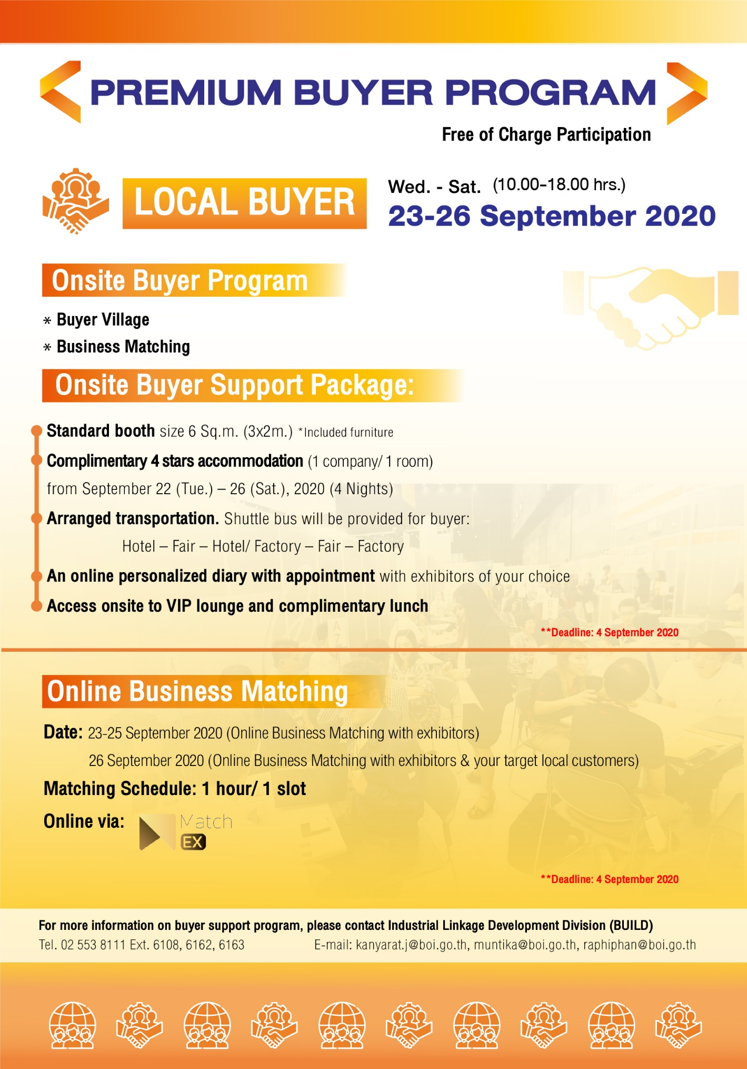
FOR LOCAL BUYERS

BUYER REPLY FORM Page 1
FOR LOCAL BUYERS

COMPANY PROFILE
Company Name |  |  |  |  | Country
Type of  Business |  | Manufacturer Procurement Unit / Department  Others (Please specify): ……………………………………….
Product / Business Details
Address
Phone |  |  |  | Fax
Website |  |  |  | BOI Promoted |  | Yes No
Contact Person  Mobile  E-mail |  |  |  | Share Holder |  | Thai ………........……%  Foreign ………………%
Looking for |  | Part Manufacturers Joint Venture Technical Collaboration  Others (Please specify): ………………………………………

BUYER PROFILE
Applicant (1) |  |  | Applicant (2)
Name |  |  | Name
Family Name |  |  | Family Name
Position |  |  | Position
Mobile No. |  |  | Mobile No.
Fax |  |  | Fax
E-mail |  |  | E-mail

We hereby apply for Buyer Support Program during SUBCON THAILAND 2020.

Date (MM/DD/YY) : ……/……/……
Authorized Signature ……………………………….
Quality Standard
ISO 9001 ISO 14001 IATF 16949 Others ……………………………....
Indicate Type of Main Industry (One or More)
Agriculture & Biotechnology Automation & Robotics Automotive
Aviation & Logistics Building & construction Electrical and Electronics
Machinery Medical Devices Plastic & Rubber
Others (Please specify): ………………………….
Interested Parts/Components for Sourcing from Thailand....................................................................
.................................................................................................................................................................................................
Products / Services (Please specify) .................................................................................................................................
.............................................................................................................................................................................................................................
Parts/ Key Manufacturing Process Required:
Electrical & Electronics Components
Cable rooms/Harnesses Control Panels Electromechanical Assembly
PCB Assembly Transformers Winding
Others (Process Only): .................................................
Metal Parts
Aluminum Die Casting Coating Extrusion Fabrication
Forging Heat Treatment Iron Casting Machining
Sintering Stamping Welding
Others (Process Only): ..........................................................................................................................
Plastic Parts
Blowing Coating Extrusion Injection Plastic Foaming
Thermoforming Others (Process Only): ....................................................................................
Rubber Parts
Calendaring Coating Extrusion Injection Molding
Press Forming Others (Process Only): ..................................................................................
Assembly Automation / Motion Technology Jig & Fixture
Logistics Mold & Die Packaging Tooling
Others (Process Only): .............................................................................................................................
SUPPLIER REQUIREMENTS Page 2
FOR LOCAL BUYERS

Please put a mark to your required programs
Buyer Onsite
1. Business Matchmaking Program (Compulsory)
Please choose your participation date(s): Sept. 23, 2020 Sept. 24, 2020 Sept 25, 2020 Sept. 26, 2020
2. A 6-sq.m. booth in the Buyer Village for exhibiting required parts and components
Please choose your participation date(s): Sept. 23, 2020 Sept. 24, 2020 Sept. 25, 2020 Sept. 26, 2020
Buyer Online
3. Online Business Matchmaking Program
Please choose your participation date(s): Sept. 23, 2020 Sept. 24, 2020 Sept 25, 2020 Sept. 26, 2020

****************************************************************************************************
** Please complete within September 4, 2020 and return this form to Ms. Kanyarat or Ms.Raphiphan**
Industrial Linkage Development Division (BUILD), Thailand Board of Investment, Thailand
E-mail: kanyarat.j@boi.go.th; muntika@boi.go.th; raphiphan@boi.go.th
Fax. +66 2 553-8325 Tel. +66 2 553 8111 ext. 6108, 6162, 6163
For more information about SUBCON THAILAND 2020, please visit the website www.subconthailand.com
****************************************************************************************************
BUYER PROGRAM (Form A)
FOR LOCAL BUYERS
Please complete information for making a reservation and other services as below ;
1. Hotel Accommodation
Room Type: Single Twin Request for Smoking Room Non-Smoking
Check-in Date ………………. Check-out Date …………………..
2. Local Transportation (During Show Day)
Hotel - Fair Site - Hotel Factory - Fair Site - Factory
TERMS AND CONDITIONS OF BUYER SUPPORT PROGRAM:
1. All applicants should submit the Buyer Reply Form. BUILD/BOI will select and confirm invitees after screening
the documents.
2. The visiting delegates are requested to bear as following:
- Hotel accommodation up to 4 nights (from Sept. 22<check in> to Sept. 25<check out> will be covered by BUILD
- Any other incurred charges/expenses listed in above such as hotel charges (e.g. telephone, bar/mini-bar costs,
non- official entertainment, etc.), gift and souvenirs, the visiting delegated are aware that they sound bring the
means to settle such expense themselves (e.g. credit cards, cash)
3. Hotel reservation for participants in Thailand will be made by BUILD. When participants wish to stay in other hotel,
the reservation and hotel charges shall be made by themselves.
4 . Buyers are required to participate in the Business Matchmaking Program (form A < No.1>) at least one day in order for
the support program to be submitted
I agree with the Teams and Conditions of contract as above
Authorized Signature : ………………………….
Company name: …….. …………………………
Date : ……………………………………………

** Please complete within September 4, 2020 and return this form to Kanyarat, Muntika or Raphiphan **
Industrial Linkage Development Division (BUILD), Thailand Board of Investment, Thailand
E-mail: kanyarat.j@boi.go.th; muntika@boi.go.th; raphiphan@boi.go.th
Fax. +66 2 553-8325 Tel. +66 2 553 8111 ext. 6108, 6162, 6163
For more information about SUBCON THAILAND 2020, please visit the website www.subconthailand.com
BUYER SUPPORT PROGRAM (Form B)
For Accommodation and Local transportation (Free of Charge)

FOR LOCAL BUYERS

